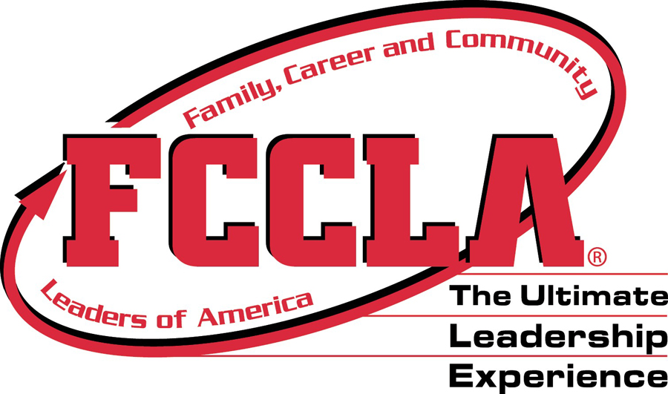
Angela Sweep | FCCLA State Adviser | angsweep98@gmail.com
1184 County Rd. 229 Lyman, WY 82937
307-780-5224

WYOMING FCCLA
  - ADVISER GUIDE

CONNECT to US!
National Website: www.fcclainc.org
State Website: www.wyfccla.org
FaceBook: Wyoming FCCLA Group Page NationalFCCLA
Wyoming FACS Teachers
Instagram: @WyoFCCLA @NationalFCCLA
Twitter: @NationalFCCLA
Pinterest: National FCCLA

Affiliation
Members must be affiliated at the State and National Level. To do this, chapter advisers must log onto the National FCCLA website at www.fcclainc.org .
State Fees: $8
National Fees: $9
A total of $17 is paid straight to Nationals and then they will send the State fee to Wyoming FCCLA.
****ALL members must be affiliated by March 1, 2020 in order to participate at State Convention. A proof of affiliation must be attached to the State Convention registration form*****

Affiliation Categories
CATEGORY 1 Grades 6-8
CATEGORY 2 Grades 9-10
CATEGORY 3 Grades 11-12

Officer Projects
Each State Officer will select a National Program to have as their project for the year. Chapters that complete the project will be recognized at State Convention. Projects will be introduced at Fall Conference and then found on the state website. www.wyfccla.org

Leadership Opportunities for Members
All Wyoming FCCLA members have the opportunity to become District Officers and/or State Officers. We are always in need of quality members to fill these positions and it is a wonderful opportunity for members to practice and enhance their leadership skills.
APPLICATIONS for all Officer Candidates are DUE March 1.
STATE OFFICER RESPONSIBILITIES:
Attend a leadership training and planning meeting for 2 days in April or May
Attend National Convention
Attend Fall Conference and planning meeting 2 days in October
Attend Legislative Days and planning meeting 2 days in February
Plan and carry out State Convention 4 days in March

DISTRICT OFFICER RESONSIBILITIES:
Attend a leadership training and planning meeting for 1 day in April or May
Plan and carry our Fall Conference 2 days in October
Attend and assist in State Convention 4 days in March

Process for selecting State Officers:
- Each Candidate will be introduced at the Opening Session
- Candidates will receive something to identify them throughout the convention as candidates and must be visible at all times.
- Candidates will meet with 2 voting delegates from each chapter to answer any questions they may have at a Delegate Reception on Wednesday Night at 6pm.
- Candidates will give a 3-5 minute speech to all members on Friday morning at the Business Session.
- Candidates must have a 2/3 vote. There can be up to 6 State Officers.
Process for selecting District Officers:
- Each Candidate will be introduced at the Opening Session
- Candidates will receive something to identify them throughout the convention as candidates and must be visible at all times.
- Each candidate will give a 2-3 minute speech at EACH of the District Meetings. (They will give the speech two times).
- Candidates must have a 2/3 vote. There can be up to 4 District Officers.

Dress Code for State Events
FCCLA Polo (Red, Black or White)
Black Pants or Skirt
Black Shoes

DATES to Remember
- October 16 Fall Conference Casper WY

- November 15 – 17 National Fall Conference Dallas TX

- February 20 REGISTRATION for STAR Events DUE to Tami

- February 10-14 National FCCLA Week

- March 1 Program Applications Due
Scholarship Applications Due
State and District Officer Application Due
AFFILIATION must be Completed

- March 12 Absolute Drop/Change Date for STAR Events

- March 25-27 State FCCLA Convention Cheyenne Little America

- July 5-9 National Leadership Conference Washington DC

Resources
New Adviser Handbook National Website Download
Chapter Adviser Facebook Page Facebook
Competitive Events Guide National Website Download
Lesson Plans and Activities National Website Downloads
National Program Resource Guides

Four Star Chapter AWARD
Based on activities throughout the year, chapters can receive recognition! To attain the highest level, the Four Star, a chapter must Affiliate Nationally, Attend Fall Leadership Conference, Participate in the Membership Drive, and complete FOUR additional programs/activities/ conferences/etc.
Details for this award can be found on our website under the STATE tab, then titled FOUR STAR CHAPTER AWARD.

STATE Level Competitions
Below is a list of competitions that are at the State level only. Winners of these competitions do not qualify to go to the National Convention. Rules and Guidelines for each one can be found on the State Website.
- Extemporaneous Speaking
- Creed Speaking
- Cake Decorating
- Fundamentals of Baking
- Quiz Bowl
- Food Art

