Food Art – Individual Event Student Name__________________ School_____________________
Score Levels | Knowledge of Food Art Techniques* | Time Management | Creativity** | Presentation
20-25 | - Competitor’s final product shows clear knowledge of Food Art techniques. | - Competitor finishes on time and does not seem rushed. Uses their time well and efficiently. | - Competitor’s final product was well thought out, very detailed, and creatively shows the Food Art aspect. | - Display reflects the artist’s intentions very well and a complete idea has been presented.
15-20 | - Competitor’s final product shows knowledge of Food Art techniques. | - Competitor finishes on time, although they may seem rushed. Uses their time well. | - Competitor’s final product was thought out, detailed, and shows the Food Art aspect. | - Display reflects the artist’s intentions and the artist’s idea has been presented.
10-15 | - Competitor’s final product does not clearly show knowledge of Food Art techniques. | - Competitor finishes on time but is rushed. Does not use time well nor efficiently. | - Competitor’s final product contains little detail, is broad, shows little amount of the Food Art aspect. | - Display somewhat reflects the artist’s intentions and an incomplete idea has been presented.
0-10 | - Competitor’s final product shows little to no knowledge of Food Art techniques. | - Competitor does not finish on time and is rushed while competing. Uses time inefficiently. | - Competitor’s Project seems rushed, very little detail, very broad, shows very little amount of the Food Art aspect. | - Display does not reflect the artist’s intentions and an idea has not been presented.

Score
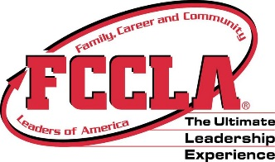
Competition Level:
Junior Consumer
Senior Consumer
Senior Occupational
Circle Rating Achieved:
Gold – 90 – 100
Silver – 70 – 89
Bronze – 0 – 69
First Tie Breaker*
Second Tie Breaker**

Total Points__________

Verification of Total Score, Please Initial

Evaluator _________
Room Consultant_________
Final Verification _________

