PARLIAMENTARY
PROCEDURE
PLANNING
2015

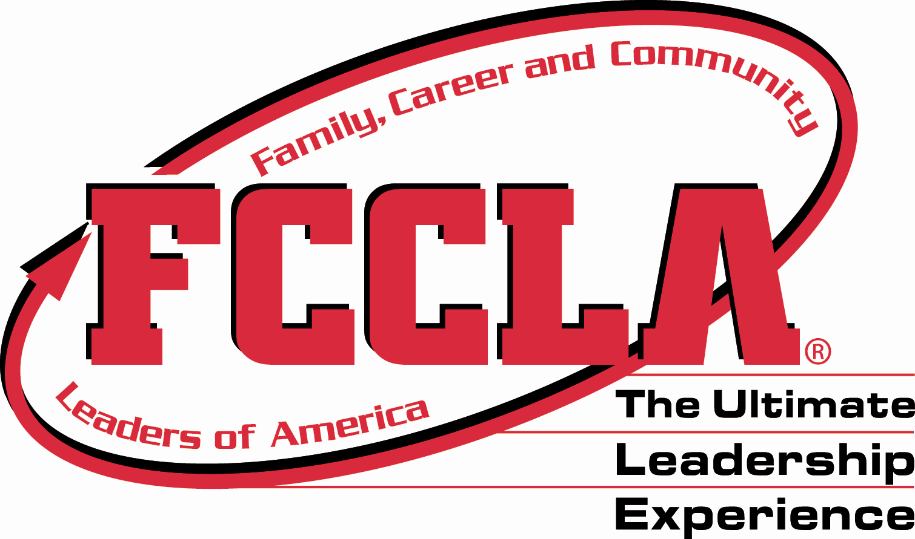

SENIOR

CATEGORY

PARLIAMENTARY PROCEDURE SENIOR CATEGORY

PARLIAMENTARY PROCEDURE

2015 STAR EVENTS

AGENDA
July 7, 2015

- Reading and Approval of Minutes

- Reports
  - Officers
  - Boards
  - Standing Committees

- Reports of Special Committees

- Special Orders

- Unfinished Business/General Orders

- New Business

- Closing Ceremony

- Adjournment

PARLIAMENTARY PROCEDURE SENIOR CATEGORY

________________________ FCCLA Chapter Minutes
April 30, 2015

The regular monthly meeting of the FCCLA Chapter was held Thursday, April 30, 2015 in the Family and Consumer Sciences Lab (Rm 101) at School. The meeting was called to order at 12:10 p.m. by President . _________________ served as secretary pro tem. The minutes of the March 7, 2015 meeting were approved as read.

The president verified the presence of a quorum. There were 19 members present.

Treasurer reported a balance on hand of $673.89.

STANDING COMMITTEES
The Fundraising Committee reported they secured a $450.00 donation from a local service organization.

The Public Relations Committee has contacted local news organizations. Two organizations will cover the walk-a-thon for hunger.

UNFINISHED BUSINESS/GENERAL ORDERS

It was moved by ___________________ to have a career fair in November. The motion being postponed to the April meeting was taken up. With further debate, the motion was amended by _____________________ to host a career fair with the Lions Club upon their acceptance of the request. The motion carried.

NEW BUSINESS
__________________ moved to have a FCCLA float in the summer community festival in August. _________________ moved to refer the motion to a committee of three, appointed by the president, to make plans and report at the next meeting. The president appointed ___________________ chairman, ________________ and ________________.

Secretary
_____________________________

Date of Approval __________________________

FCCLA CHAPTER

PARLIAMENTARY PROCEDURE SENIOR CATEGORY

Financial Report
July 7, 2015

Balance on Hand, April 30, 2015 $673.89

Receipts

Donation from local service organization for NLC travel $450.00
Candle Sale Fundraiser $250.00
Breadsticks Fundraiser Donations $350.00

Total Receipts $1050.00

Disbursements

Supplies for STAR Events competition $250.00
Contribution for two delegates to
National Leadership Conference $750.00
Promotional Materials for member recruitment $150.00

Total Disbursements $1150.00

Balance on Hand, July 7, 2015 $573.89

Treasurer
____________________________________
PARLIAMENTARY PROCEDURE SENIOR CATEGORY

NEW BUSINESS

- The chapter officers would like to establish a leadership training program to help younger members recognize their leadership potential.

- A local community center asked the chapter to assist with a project about child abuse.

- A local service organization has asked the chapter to make a presentation about the benefits of FCCLA business partnerships.

- The chapter needs to prepare a recruitment table for the annual student organization and club recruitment day at school.

- A local news program would like to feature the chapter in a story about how student leaders are making changes in our dining habits.

- How can the chapter partner with the athletic department to showcase our Sports Nutrition STAR Event and improve team performance?

