PARLIAMENTARY
PROCEDURE
PLANNING
2016

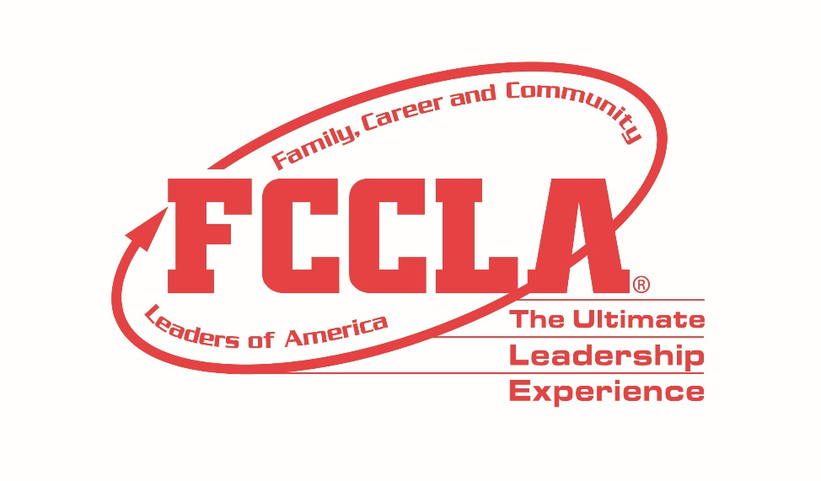

JUNIOR
CATEGORY

PARLIAMENTARY PROCEDURE JUNIOR CATEGORY

PARLIAMENTARY PROCEDURE

2016 STAR EVENTS

AGENDA
July 5, 2016

- Reading and Approval of Minutes

- Reports
  - Officers
  - Standing Committee
  - Special Committees

- Special Orders

- Unfinished Business/General Orders

- New Business

- Closing Ceremony

- Adjournment

PARLIAMENTARY PROCEDURE JUNIOR CATEGORY

________________________ FCCLA Chapter Minutes
June 1, 2016

The regular monthly meeting of the _____________ FCCLA Chapter was held on Wednesday, June 1, 2016 in the school Child Growth Room at ___________ School. The meeting was called to order at 2:45 p.m. by President _______ . The minutes of the Wednesday, May 4, 2016 meeting were approved as read.

The president verified the presence of a quorum. There were 24 members present.

Treasurer ____________ reported a balance on hand of $415.16.

STANDING COMMITTEES
The Membership Committee chairman moved that the chapter should host a FACS Info Fair as a membership recruitment tool. The motion was approved. The Membership Committee was directed to report the details of the plan at the July 5 chapter meeting.

UNFINISHED BUSINESS/GENERAL ORDERS
The motion by __________________, to complete an FCCLA public relations project by creating a bulletin board for the first day of the 2016-2017 school year was referred to a committee of three, to be appointed by the president and is to report at the July 5 meeting. The motion to refer was adopted. The president appointed _________________ chairman, ______________, and ____________ with instructions to report at the next meeting.

NEW BUSINESS
__________________ moved to participate in a Lead2Feed initiative to stock the local food pantry for the summer months. _______________ moved to postpone the motion to the July meeting. The motion to postpone was adopted.

Secretary
_____________________________

Date of Approval ________________________

________________FCCLA CHAPTER

PARLIAMENTARY PROCEDURE JUNIOR CATEGORY

Financial Report
July 5, 2016

Balance on Hand, May 4, 2016 $415.16

Receipts

After School Smoothie Sales $ 120.00
Earth Day Plant Sales $ 66.00

Total Receipts $186.00

Disbursements

Ingredients for Smoothies $ 20.00
Recognition pins for members $ 50.00
FACS Guest Speaker $ 100.00

Total Disbursements $170.00

Balance on Hand, July 5, 2016 $431.16

Treasurer

____________________________________

PARLIAMENTARY PROCEDURE JUNIOR CATEGORY

NEW BUSINESS

- Your chapter has been asked by the school to create a booth for your school’s annual club fair.

- FCCLA chapter plans to donate money to the local chapter of the American Cancer Society. What activities can your chapter do to raise funds?

- Your chapter is trying to increase membership this year. What events can you hold to promote and publicize FCCLA?

- The Board of Education may pass legislation that will cut funding for the Child Growth and Development preschool program in your school. What can your chapter do to voice your concerns?

- Your chapter has been asked to organize an event to promote the National Program, Student Body, at your school’s field day.

- Middle school students are reluctant to run for office. What can your chapter do to take leadership positions and to encourage younger members to run for office?

