PARLIAMENTARY
PROCEDURE
PLANNING
2016

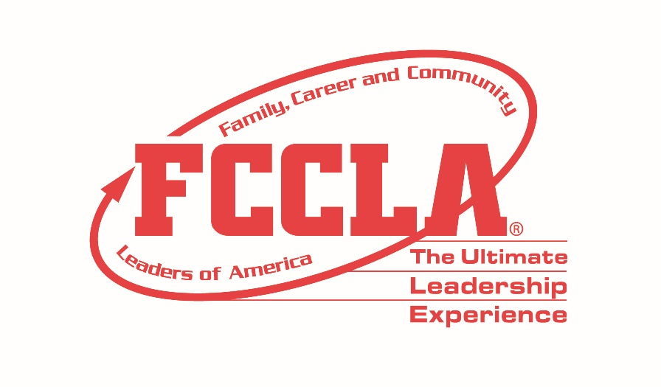

OCCUPATIONAL
CATEGORY

PARLIAMENTARY PROCEDURE OCCUPATIONAL CATEGORY

PARLIAMENTARY PROCEDURE

2016 STAR EVENTS

AGENDA
July 5, 2016

- Reading and Approval of Minutes

- Reports
  - Officers
  - Boards
  - Standing Committees

- Reports of Special Committees

- Special Orders

- Unfinished Business/General Orders

- New Business

- Closing Ceremony

- Adjournment

PARLIAMENTARY PROCEDURE OCCUPATIONAL CATEGORY

________________________ FCCLA Chapter Minutes
June 1, 2016

The regular monthly meeting of the ___________ FCCLA Chapter was held Wednesday, June 1, 2016 in the Multi-Purpose Room at _________ School. The meeting was called to order at 3:30 p.m. by President __________. The minutes of the May 4, 2016 meeting were approved as read.

The president verified the presence of a quorum. There were 17 members present.

Treasurer ___________ reported a balance on hand of $995.92.

STANDING COMMITTEES

The Leadership Service in Action Committee chairman has identified several opportunities for our chapter to participate in leadership service activities in our community. We will begin writing letters to patients of a local children’s hospital every month.

UNFINISHED BUSINESS/
The motion to hold a Health Fair for the public, which was postponed from the last meeting, was taken up. After amendment and further debate, the motion by _______________________was adopted as follows: to hold a Health Fair for the public, featuring a zumba session with an instructor who is an FCCLA alumnus. Without objection the president appointed ______________, chairman, ____________ and ___________________ to make the necessary arrangements and report back to the next meeting.

NEW BUSINESS
__________________moved to organize a Career Connection workshop to provide an opportunity for students and community members to hear from FACS professionals in content areas ranging from food services to fashion design. ______________ moved to postpone the motion to the next meeting. The motion to postpone was adopted.

Secretary
_____________________________

Date of Approval __________________________

____________________ FCCLA CHAPTER

PARLIAMENTARY PROCEDURE OCCUPATIONAL CATEGORY

Financial Report
July 5, 2016

Balance on Hand, June 1, 2016 $995.92

Receipts

Impact Fund Grant from FCCLA $500.00
Car Wash $167.00
NTHS Induction Reception Catering $77.00

Total Receipts $744.00

Disbursements

Zumba Instructor Stipend $ 100.00
New FCCLA Showcase $ 549.00

Total Disbursements $649.00

Balance on Hand, July 5, 2016 $1090.92

Treasurer
____________________________________

PARLIAMENTARY PROCEDURE OCCUPATIONAL CATEGORY

NEW BUSINESS

- The chapter is looking for ways to involve members in internships with business and industry partners.

- The FCCLA chapter has been asked to develop a program to inform and advocate for teen safe driving in the school.

- Your chapter has been granted the opportunity to hold a coffee shop music event to raise funds for your chapter. How will you organize the implementation and organization of the shop to include all chapter members?

- The district CTE Director has asked the chapter to make a presentation about the benefits of FCS business partnerships.

- There is current state legislation that will negatively affect funding for Family and Consumer Sciences programs in our state. How can the chapter address this issue to keep FCS courses in high schools?

- We need to expand our leadership beyond the chapter level and encourage our members to seek local and state officer positions. What activities can you do to encourage younger members to take the lead?

