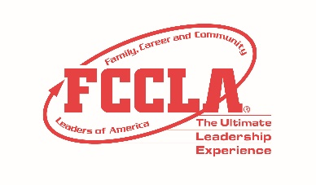
FCCLA STAR Events
Promote and Publicize FCCLA!
Writing Sample
Junior

Please complete the writing sample in the next 10 minutes. You should fill in the information at the top of the page and write your final response to the scenario in the space provided on the sheet. Prior to your presentation, you will turn in only the single sheet of your completed writing sample to your evaluators. You do not have to orally present your response to the evaluators. Please leave this paper and the writing sample with the Writing Sample Room Consultants. Good luck!

A new FCCLA chapter has formed at your school. To educate the school on the organization, you have chosen to partner with the school radio station to create a short public service announcement. Create the script for the public service announcement that will be aired on the school radio station.

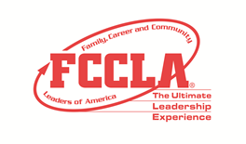
FCCLA STAR Events
Promote and Publicize FCCLA!
Writing Sample
Occupational

Please complete the writing sample in the next 10 minutes. You should fill in the information at the top of the page and write your final response to the scenario in the space provided on the sheet. Prior to your presentation, you will turn in only the single sheet of your completed writing sample to your evaluators. You do not have to orally present your response to the evaluators. Please leave this paper and the writing sample with the Writing Sample Room Consultants. Good luck!

National FCCLA is looking for input on where to have a future National Leadership Conference. Write a letter from your FCCLA chapter to National FCCLA as to why the National Leadership Conference should be in your home state.

FCCLA STAR Events
Promote and Publicize FCCLA!
Writing Sample
Senior

Please complete the writing sample in the next 10 minutes. You should fill in the information at the top of the page and write your final response to the scenario in the space provided on the sheet. Prior to your presentation, you will turn in only the single sheet of your completed writing sample to your evaluators. You do not have to orally present your response to the evaluators. Please leave this paper and the writing sample with the Writing Sample Room Consultants. Good luck!

During your community fair, your FCCLA chapter hosts a breakfast to raise money for a local charity. Write content to be used by your school district in their Twitter and Facebook posts. Provide content for one week prior to the event, the day before the event, and the day of the event.

