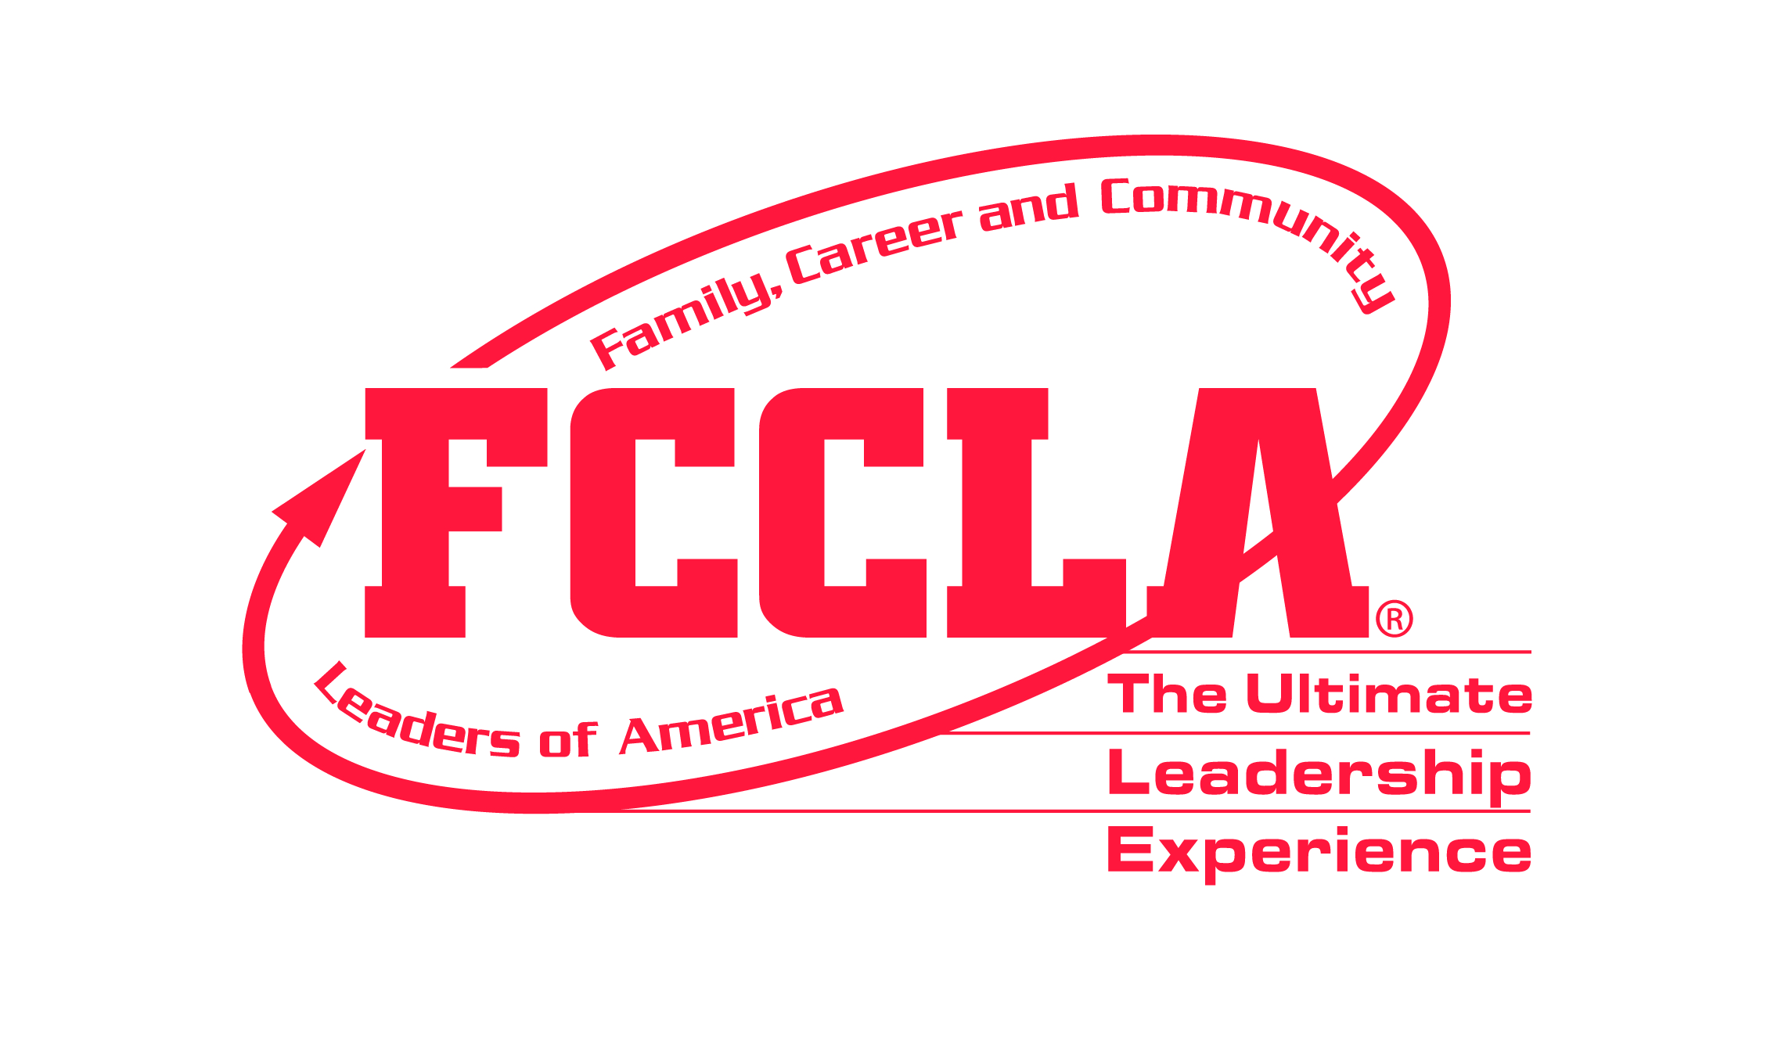
INTERPERSONAL COMMUNICATIONS

CASE STUDIES

JUNIOR

Select the category that relates to your communications project. Prepare a 3 to 5 minute response to the category case study. You have 10 minutes to prepare your response, and may use the provided note cards.

Community
Your city’s parks and recreation division has asked your FCCLA chapter to clean up the local parks the first Saturday in August. You presented the idea to your chapter members, but they do not want to give up their Saturday.

How would you use interpersonal communication to handle this situation?

EMPLOYMENT RELATIONSHIPS
You mow your neighbor’s lawn twice a month, but you have not been paid the past three times.

How would you use interpersonal communication to handle this situation?

FAMILY
Your uncle has been involved in an accident and has two broken legs. Since he is not able to care for himself, he has come to live with your family for the remainder of the summer. Your parents both work and you are expected to stay home and care for your uncle rather than go out with your friends.

How would you use interpersonal communication to handle this situation?

PEER GROUPS
One of your friends is hosting a giant birthday party, but you were not invited.

How would you use interpersonal communication to handle this situation?

SCHOOL GROUPS
You and a classmate had the exact same answers on an assignment and the teacher confronts you for cheating, even though you did not copy the assignment.

How would you use interpersonal communication to handle this situation?

INTERPERSONAL COMMUNICATIONS

CASE STUDIES

SENIOR

Select the category that relates to your communications project. Prepare a 3 to 5 minute response to the category case study. You have 10 minutes to prepare your response, and may use the provided note cards.

Community
The Firefighters Association is hosting a pancake fundraiser and they want your FCCLA chapter to run the event. However, several weeks ago the chapter planned to have a pool party on the same day.

How would you use interpersonal communication to handle this situation?

EMPLOYMENT RELATIONSHIPS
You helped your best friend get a job at the fast food restaurant where you have worked for the past two years. He has proved to be an unreliable worker, showing up late or not at all, and your boss is looking to you to make sure he pulls his weight.

How would you use interpersonal communication to handle this situation?

FAMILY
You suspect that your 15-year-old sister has been taking the family car out for joy rides.

How would you use interpersonal communication to handle this situation?

PEER GROUPS
Your best friend from the basketball team and your closest co-worker from your weekend job are both running for student council president and they have both asked you to be their campaign manager.

How would you use interpersonal communication to handle this situation?

SCHOOL GROUPS
Because of an incident last year, the school has cancelled the Homecoming Dance in the fall. As a leader in the school and someone who has a good relationship with the administration, your friends and classmates are pressuring you to make sure there is a dance this year.

How would you use interpersonal communication to handle this situation?

INTERPERSONAL COMMUNICATIONS

CASE STUDIES

OCCUPATIONAL

Select the category that relates to your communications project. Prepare a 3 to 5 minute response to the category case study. You have 10 minutes to prepare your response, and may use the provided note cards.

Community
The recreation department where you volunteer has placed you in charge of their annual Halloween party for needy children in the community. You have not been given a budget or any direction other than the date. Your supervisor is not responding to your questions.

How would you use interpersonal communication to handle this situation?

EMPLOYMENT RELATIONSHIPS
You are carrying a heavy school work load this semester, but your employer keeps scheduling you for late shifts on school days. When you get home, you do not have time to finish your homework and get enough sleep.

How would you use interpersonal communication to handle this situation?

FAMILY
Your parents' work schedules are irregular and they often need you to stay home and care for your 3-year old sister. They often do not give you much notice, so you do not have time to get off from work and your boss is angry that you frequently call in for a last minute replacement.

How would you use interpersonal communication to handle this situation?

PEER GROUPS
You see your friend stealing food from the school’s culinary lab.

How would you use interpersonal communication to handle this situation?

SCHOOL GROUPS
Several students have been verbally harassing the new transfer student. She has reported their abuse to the school’s guidance office, but no action has been taken.

How would you use interpersonal communication to handle this situation?

