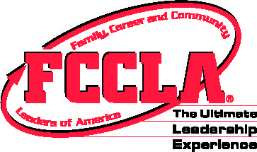
FCCLA STAR Events
Promote and Publicize FCCLA!
Writing Sample
Junior

Please complete the writing sample in the next 10 minutes. You should fill in the information at the top of the page and write your final response to the scenario in the space provided on the sheet. Prior to your presentation, you will turn in only the single sheet of your completed writing sample to your evaluators. You do not have to orally present your response to the evaluators. Please leave this paper and the writing sample with the Writing Sample Room Consultants. Good luck!

On the way to the National Leadership Conference, your chapter is wearing FCCLA attire and sporting backpacks that say, “FCCLA National Competitors 2015”. The gentleman sitting beside you on the plane says, “I notice you’re group is part of some organization, where are you going and what is it all about?” Write your explanation to the gentleman. Make sure he walks away with a better understanding of what FCCLA is/does.

FCCLA STAR Events
Promote and Publicize FCCLA!
Writing Sample
Occupational

Please complete the writing sample in the next 10 minutes. You should fill in the information at the top of the page and write your final response to the scenario in the space provided on the sheet. Prior to your presentation, you will turn in only the single sheet of your completed writing sample to your evaluators. You do not have to orally present your response to the evaluators. Please leave this paper and the writing sample with the Writing Sample Room Consultants. Good luck!

You are writing to a local Congressman asking them to attend your State Leadership Conference. Write a letter of invitation explaining what takes place at State Leadership Conference. Include why you believe it would be beneficial to them, as well as the organization, to be in attendance.

FCCLA STAR Events
Promote and Publicize FCCLA!
Writing Sample
Senior

Please complete the writing sample in the next 10 minutes. You should fill in the information at the top of the page and write your final response to the scenario in the space provided on the sheet. Prior to your presentation, you will turn in only the single sheet of your completed writing sample to your evaluators. You do not have to orally present your response to the evaluators. Please leave this paper and the writing sample with the Writing Sample Room Consultants. Good luck!

A local television station read that your FCCLA chapter won the National Programs Award at the 2015 National Leadership Conference and would like to broadcast an interview with you about the student leadership organization. What would you say in this interview? Be sure to include how individuals watching the interview can learn more or even get involved.

